**Flight Live Tracking**

**Description**

On various Airports the key point is to track the various flights that are present at the airport. Which Airplanes are available and help you understand the overall Flight distributions by Google maps This module can help you set up initial functionalities and UI for this purpose. These functionalities can be further customized according to requirements.

**Typical Usage Scenario**

This can be used for live tracking of all the flights at the respective airport.

· Managing flights in an optimized way.

· Dynamic values of flights and airports can be passed.

· User can further customize the Airplane position locations like (Onboarding, Departure, No flying zone etc.)

**PreRequisites**

NA

**Features and Limitations**

**Features**

1. It is easy to monitor various airplanes with their overview of different various locations.
2. Can be customized further.

**Limitations**

1. Mendix only supports decimal values up to 8 values after perception. Accuracy can be a concern because of this.
2. Mendix Map can only support Decimal values, so it gets hard to use String values and later convert them for better accuracy.

**Dependencies**

Require Mendix 9.12.5 or higher

**Installation**

1. Download this module from Mendix Marketplace.
2. Add a button on the UI page and call this. Microflow: ACT_Step1InitalConfiguration. (*This is just for the initial data load so that you can use a sample application before loading actual Data). Can be accessed by Admin role.*
3. Add Step2Airport_Overview page to access and use it.
4. To show map view on some page for the respective airport use Step3SNIP_AirportFlightsLocations.
5. Sub_FlightNextPhase is microflow already used in this flow but can be used explicitly to change flight phase.

## **Screenshots**

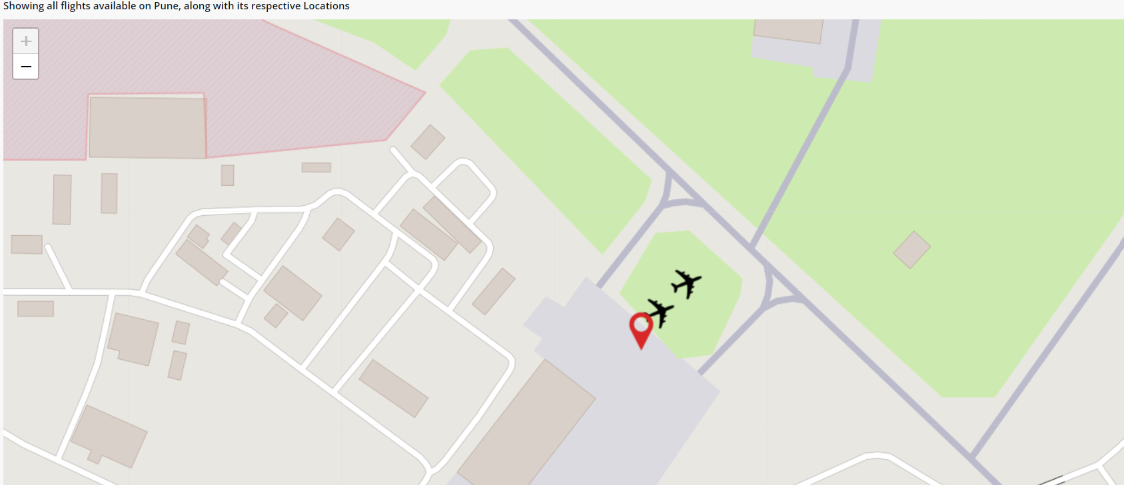

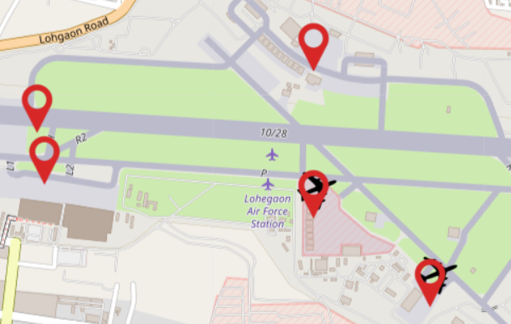

**Configuration: NA**

**Category: Module**

**Subcategory: All**

**Visibility: Public Marketplace**

**Studio Pro Version: 9.12.5**